1. This journal is focused on the basics of cisco packet tracer. As well as the setup of a simple network and basic router configuration.

2.

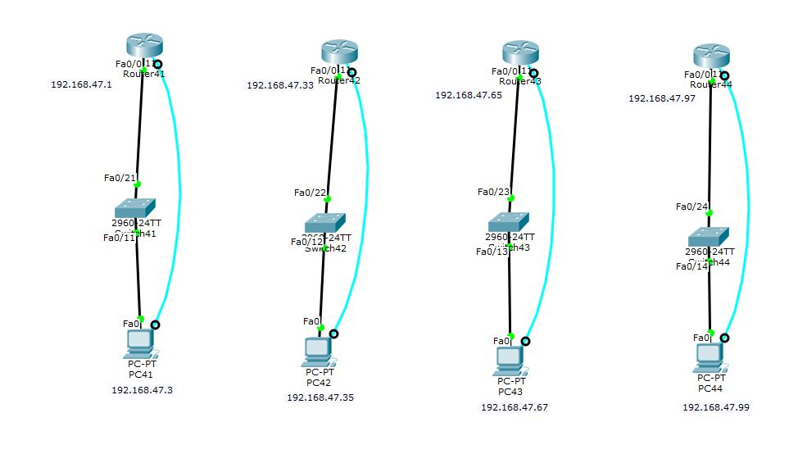

3.

|  |  |
| --- | --- |
| Command | Description |
| Enable | Enter privileged mode |
| Hostname | Give the device a host name |
| Enable password cisco | Set the password for privileged mode to cisco |
| Line con 0 | Enter line configuration mode |
| Password cisco | Set password for line configuration mode to cisco |
| Login | Force password on entering line configuration mode |
| Exit | Exit current mode |
| Int f0/0 | Enter configuration mode for port f0/0 |
| Ip address #.#.#.# #2.#2.#2.#2 | Set ip address of port to #.#.#.# and mask to #2.#2.#2.#2 |
| No shutdown | Enable the port |

4.

PC1:

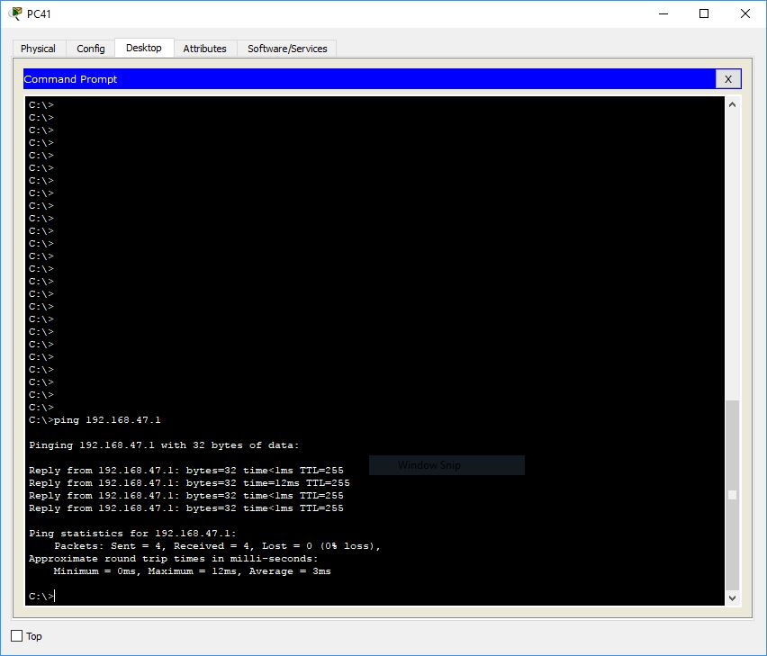

PC2:

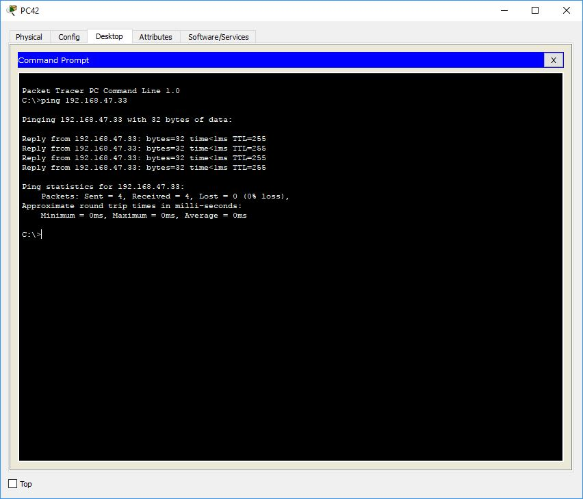

PC3:

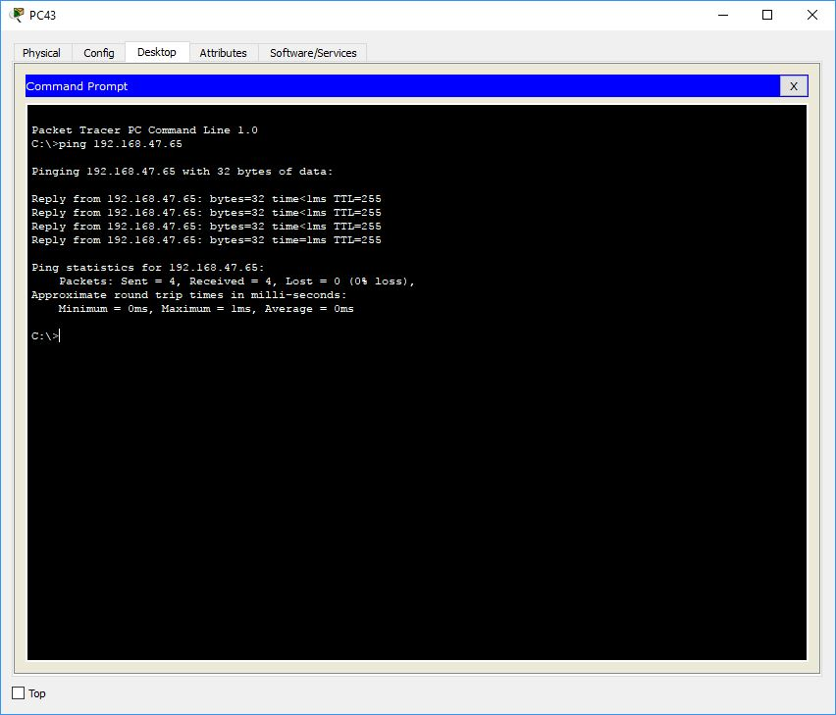

PC4:

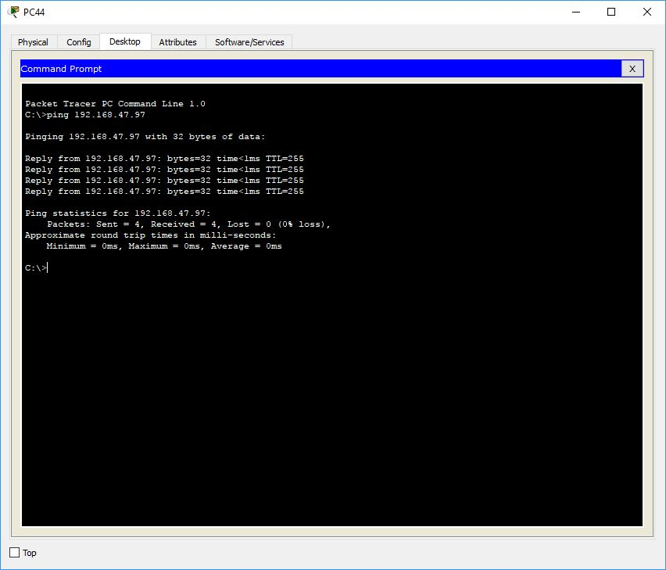

5. Results / Outcomes: Everything seemed to work. One thing I did learn is I needed to schedule way more time to finish these lab journals on time.